HMT Watches – Microsoft Clarity Analysis
EXPERIMENT - 06
Name | Anish Bandal
PRN | 1032240033
Panel | D
Subject | UI/UX
Experiment | 06

1. Clarity Dashboard
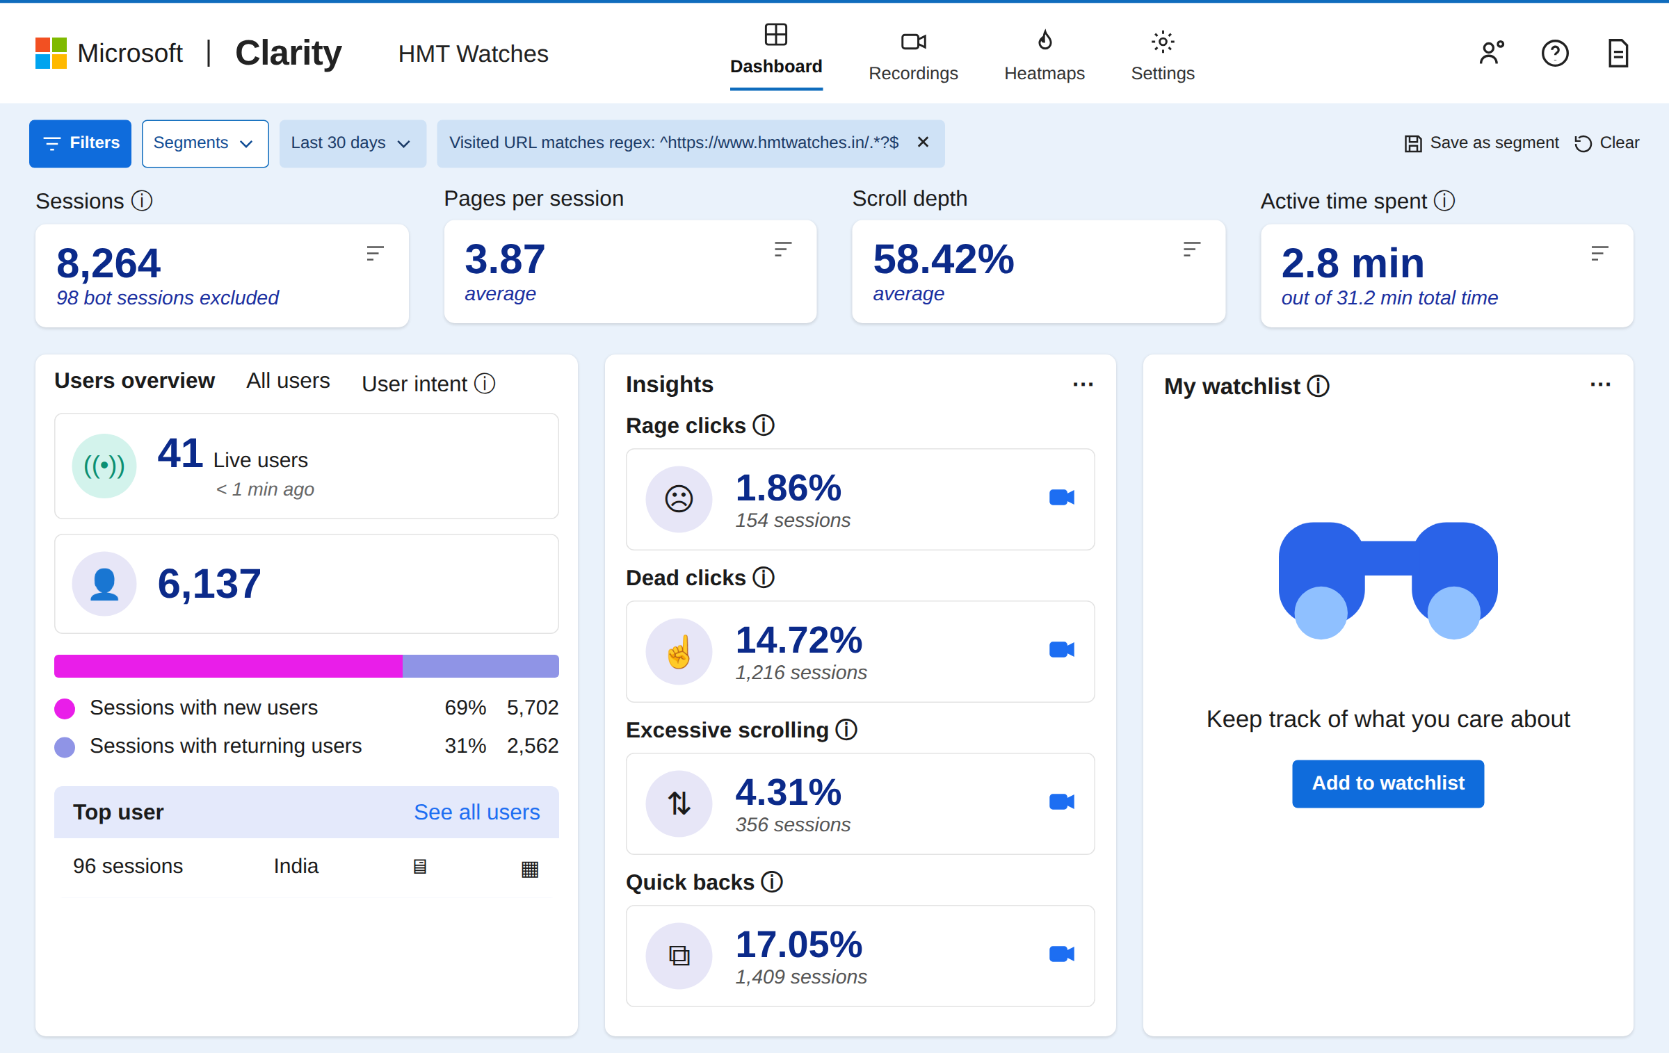
Figure 1: Dashboard overview for HMT Watches (last 30 days): sessions, pages per session, scroll depth, active time and behaviour insights.

2. Session Recording 1 – Home Page
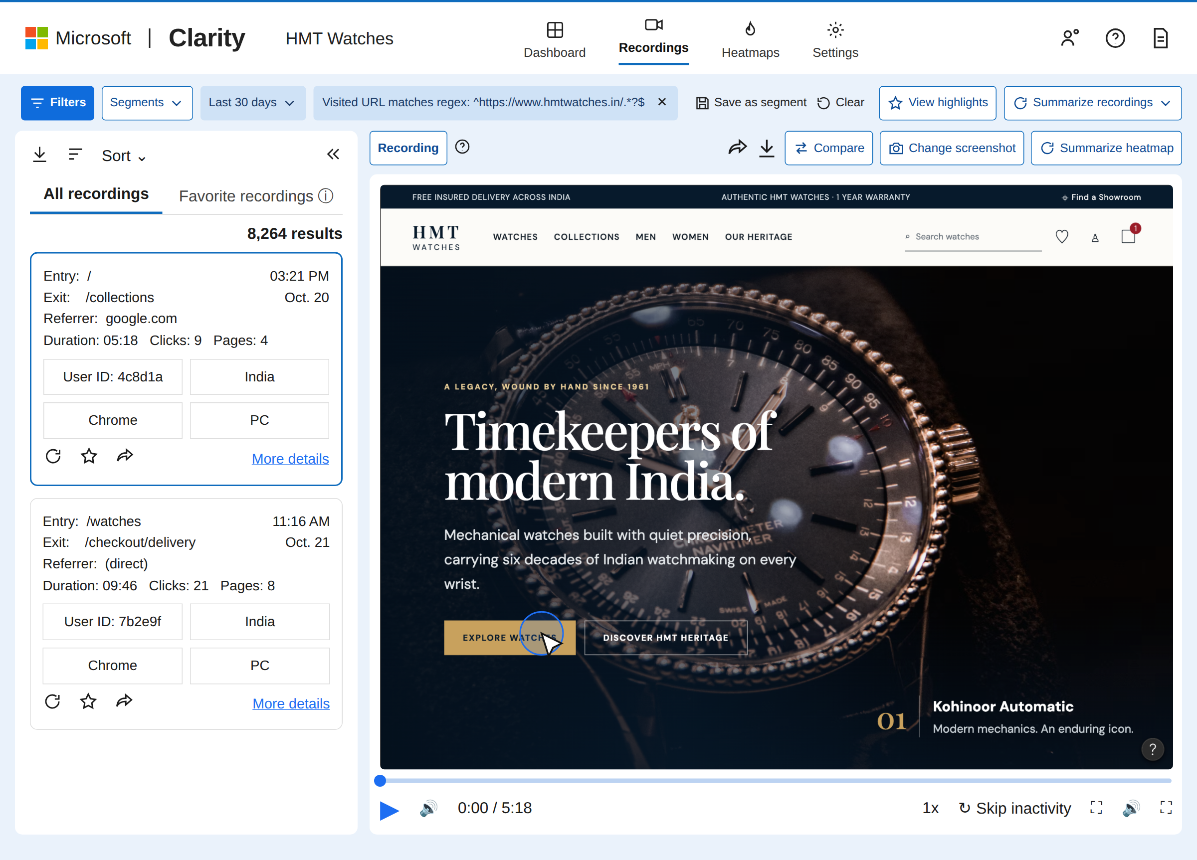
Figure 2: Session recording list with a visitor landing on the home page and hovering over the “Explore Watches” button.

3. Session Recording 2 – Cart Page
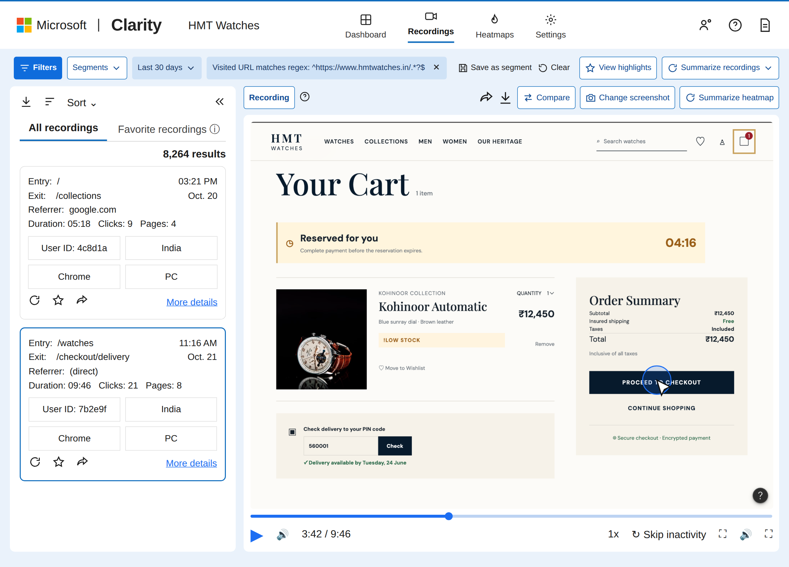
Figure 3: Session recording of a visitor on the cart page, moving towards “Proceed to Checkout” while the reservation timer runs.

4. Click Heatmap – Home Page
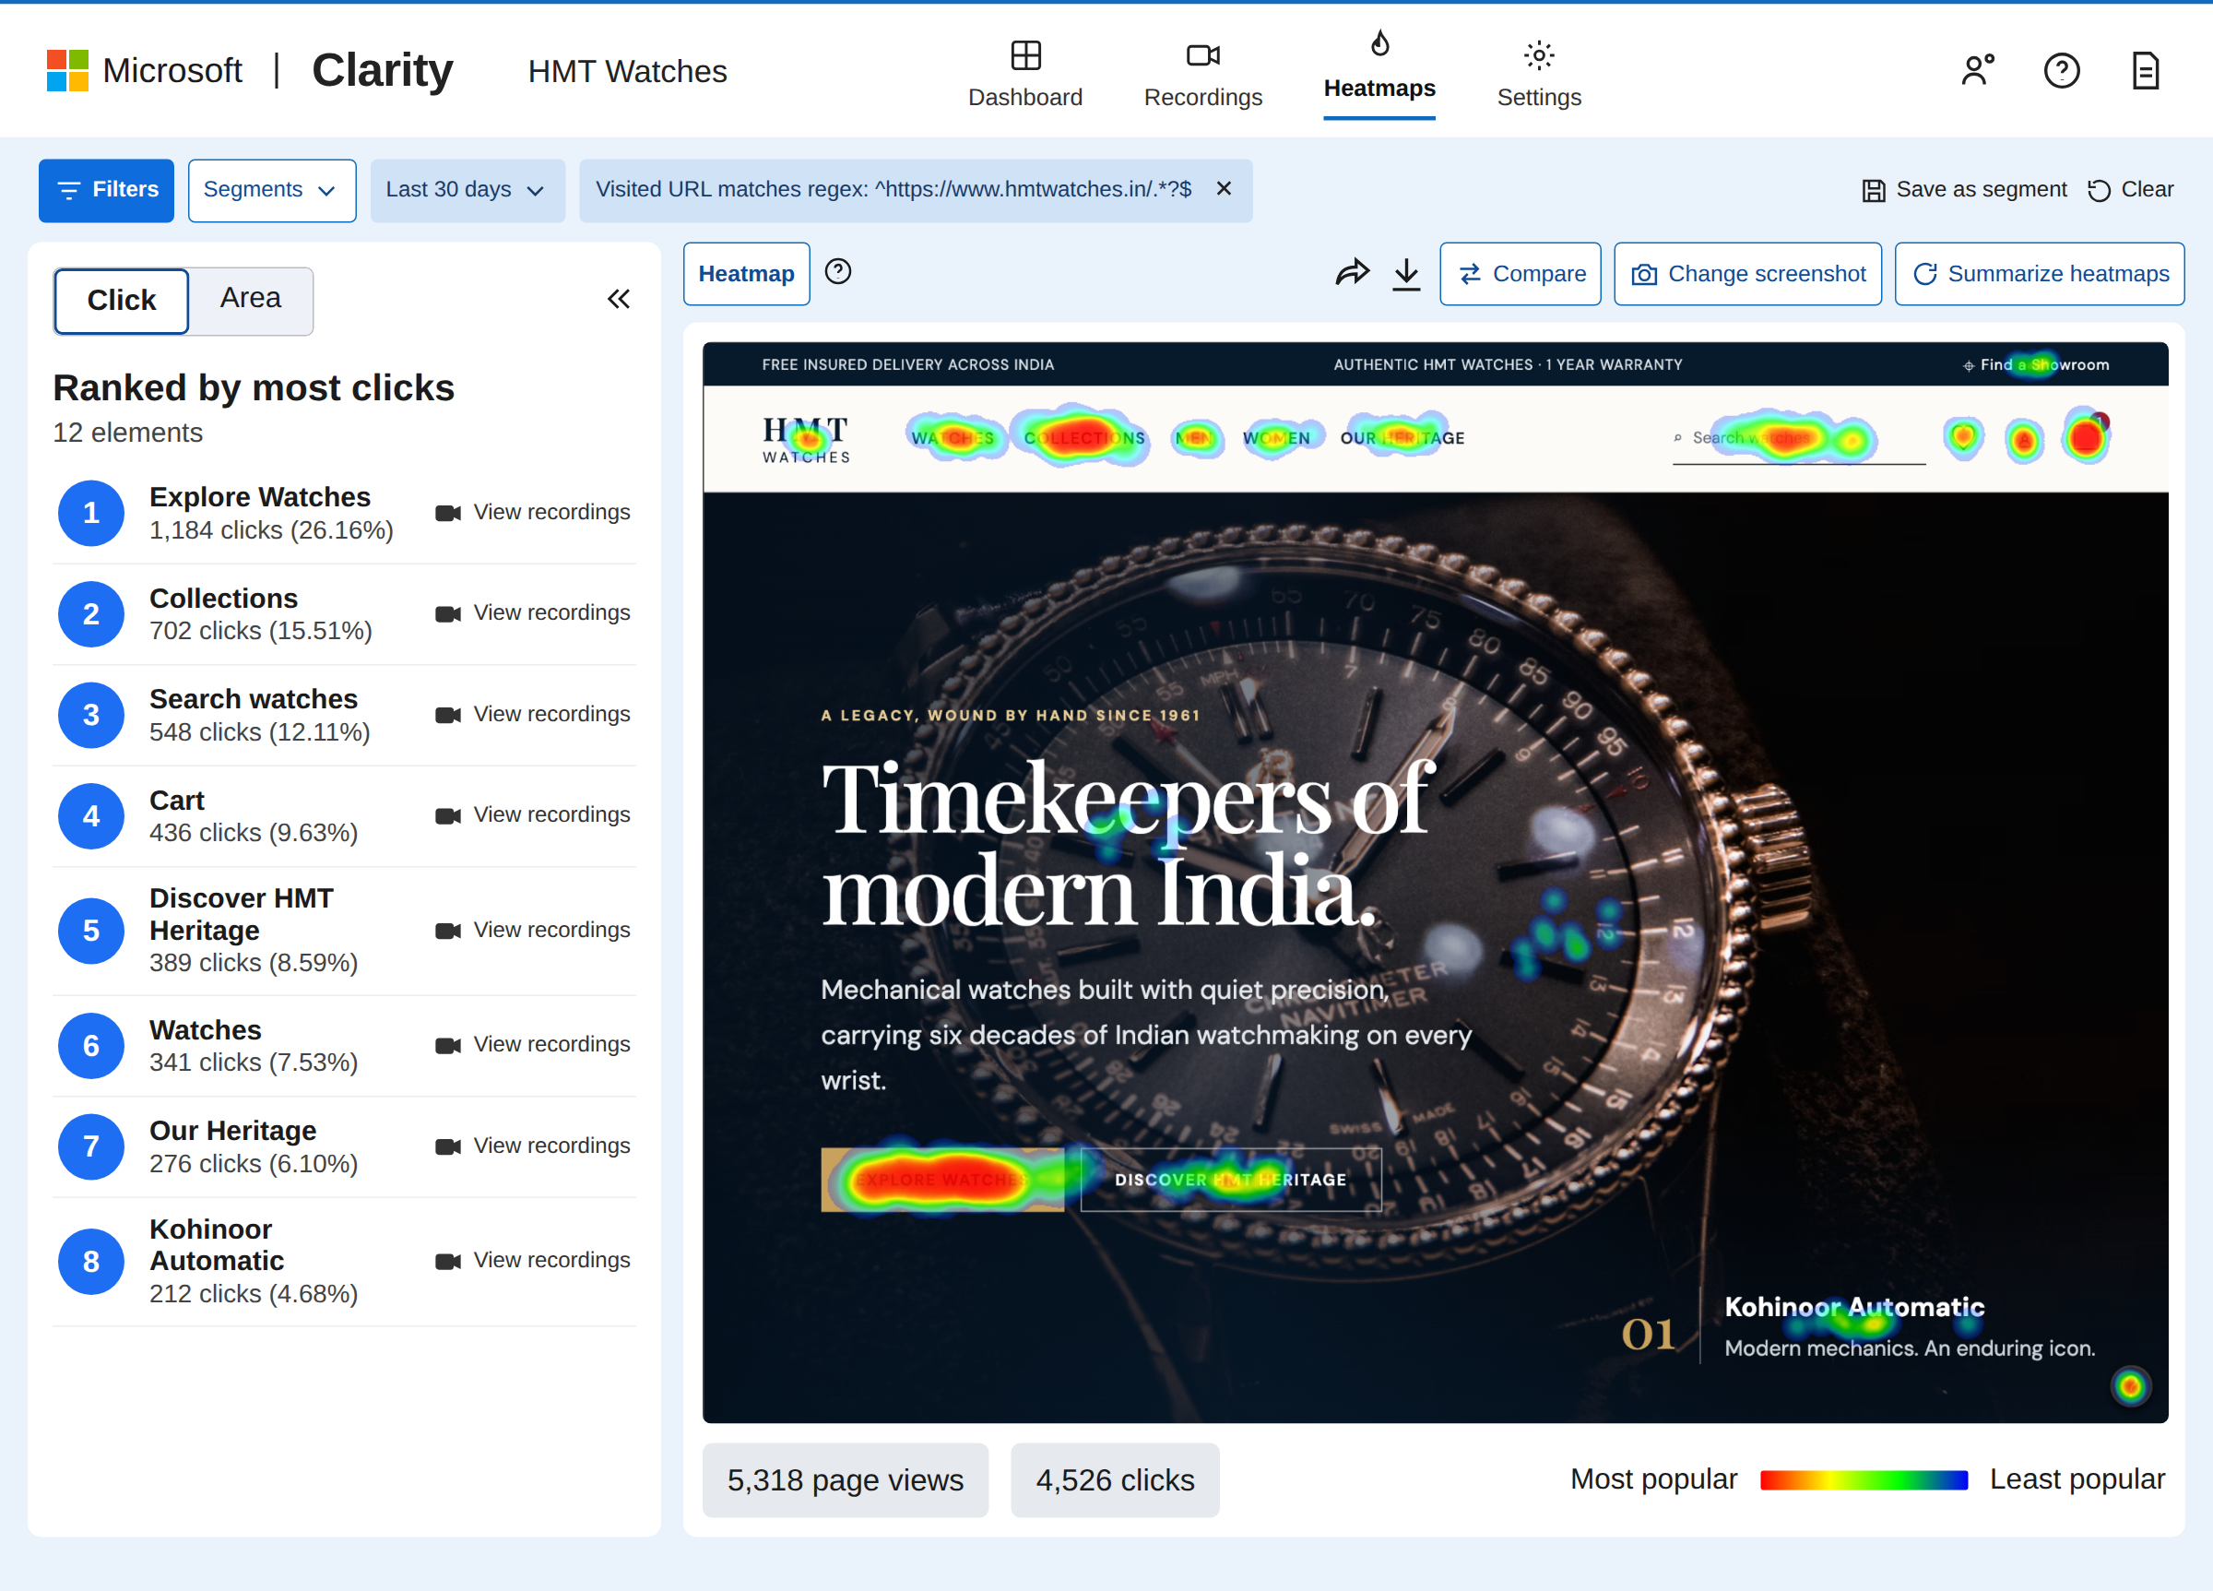
Figure 4: Click heatmap of the home page with the elements ranked by number of clicks.

5. Attention Heatmap – Home Page
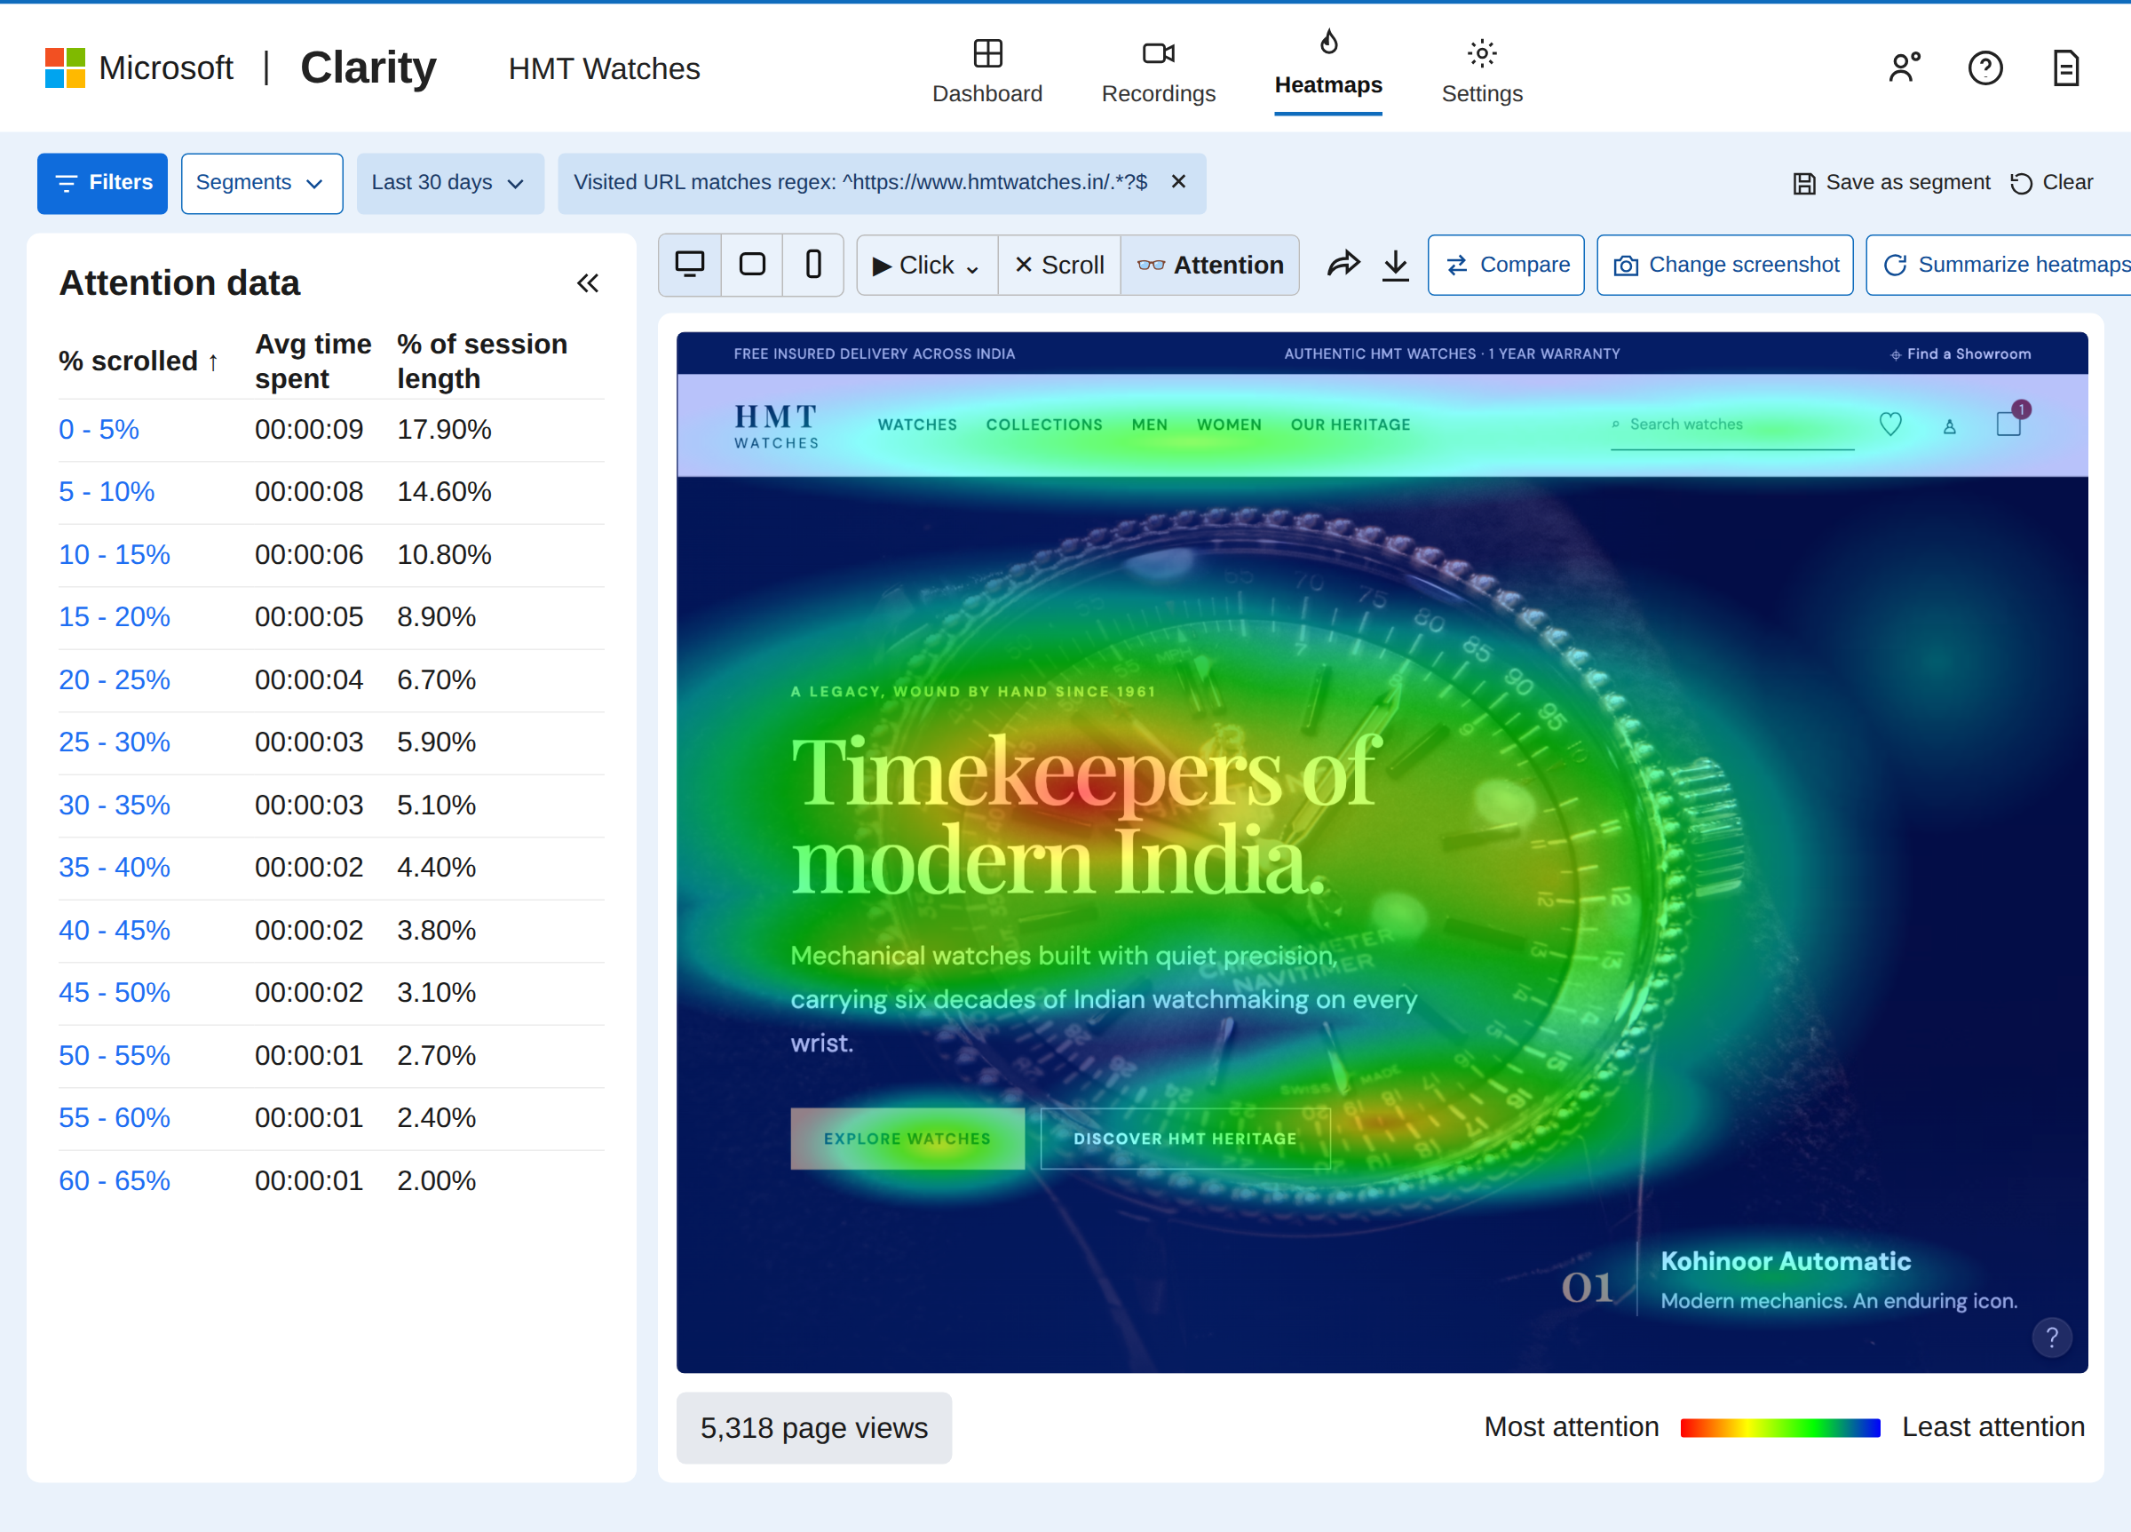
Figure 5: Attention heatmap showing where visitors spent the most time on the home page.

